**Rasul 9.2.2016**

**Optimization problem**

**Introduction**

The purpose of the optimization problem is searching for an optimum point in different Ns/Nr combinations (6/4, 8/6, 12/8, 18/12) in which torque density reaches its maximum value. In other words, finding an optimum geometry of switched reluctance motors which leads to the maximum torque per motor active mass is aimed. Production cost of electrical machines is one of the most important factors that has to be taken into account in any design process. Because material prices are changed over time, selection of an objective function based on material cost of the machine is not logical. Therefore, active mass of the machine which can be considered as a representative of the material cost will be considered as a parameter in specifying the objective function of the optimization. The motor is also required to have the best possible performance while the production cost of the machine is minimized. Output torque can be a suitable parameter to measure motor performance capabilities. For this purpose, a combination of mean output torque which is the representative of motor performance and motor active iron and copper mass which gives an insight about material cost of the machine will be considered as the objective function of the optimization. In other words, the ratio of motor average output torque to motor active mass will be defined as the torque density of the machine and is considered as the objective function of optimization. Motor active mass is computed by summing up total copper weight and iron weight (except the shaft).



In this equation TMM stands for Torque per Motor Mass which is the objective function of the optimization problem, and has to be maximized under certain circumstances.

Because the mass of the machine is considered in defining the objective function, dimensions of the machine have to be specified in order to compute active mass. Furthermore, in order to design winding configuration and drive circuit ratings, determination of motor dimensions is necessary. For this purpose, basic dimensions of a typical SRM motor designed to be used in Hybrid Electric Vehicle (HEV) applications [Akira] are considered for all motors studied in this study. Following table summarizes basic dimensions and characteristics of SRM motors which are considered to be constant among all motors simulated during optimization procedure. Once the basic dimensions (Dor and L) of the machine are specified, an initial design will be carried out to design stator and rotor back core and teeth areas for SRM motors. A detailed discussion on this design process is given in this chapter. However, in “dimensionless nature of the problem” section it will be proved that the objective function in this study is independent from motor dimensions, and the attained optimization results are universally valid. Hence, the optimization results can be helpful in designing any kind of switched reluctance motors to be used in various applications, and for a wide range of output powers.

|  |  |  |  |  |
| --- | --- | --- | --- | --- |
| Parameter | Speed | DC voltage | Stator outer diameter (Dos) | Motor axial length (L) |
| value | 1200 rpm | 500 V | 269 mm | 155mm |

In this optimization problem with the defined objective function, Stator poles/rotor poles (Ns/Nr), rotor tooth pitch per air gap length ratio (λ/g), normalized stator and rotor teeth widths (ts/λ and tr/λ), rotor outer diameter (Dor), excitation period and phase turn on angle are taken as seven independent variables of the optimization. Note that, determination of optimum values of machine geometry and excitation pattern in order to maximize the torque density for each pole combination is aimed in this study. Following sections discuss independent variables and constant parameters of the optimization in details. Furthermore, dependent variables will be introduced, and the SRM will be initially designed for optimization purposes. Finally, the procedure used in optimizing motor geometry to reach maximum torque per motor active mass, and optimization results will be discussed.

**Independent variables of the optimization problem**

This section summarizes the variables which change independently during optimization procedure. Because the proposed method tries to introduce a general method to find an optimum geometry to maximize torque density in switched reluctance motors, the independent variables determine general geometry characteristics of the machine. The independent variables of the optimization are

1. Ns/Nr

There are some common standard values for number of stator and rotor poles which designer can choose from based on the specific application. Because the converter configurations and drive circuits are designed for standard number of stator and rotor poles, deviation from standard values is not advised and is done only in some exceptional applications. Choosing Ns/Nr ratio determines number of phases of the machine and basically depends on the application criteria. Following equation is used to determine number of phases based on number of stator and rotor poles.



In above equation q represents number of phases of the machine. The denominator of the fraction is Greatest Common Divisor of number of stator and rotor poles. Standard numbers for stator and rotor poles and number of phases in each combination are summarized in following table.

|  |  |  |  |  |
| --- | --- | --- | --- | --- |
| Ns / Nr | 6/4 | 8/6 | 12/8 | 18/12 |
| q (number of phases) | 3 | 4 | 3 | 3 |

1. λ/g

The ratio of λ/g determines the air gap of the machine based on rotor pole pitch value. Rotor pole pitch value can be easily calculated using



Where Dor stands for the rotor outer diameter. Because developing a general design methodology for switched reluctance machines is aimed in this study, normalized sets of force and permeance data are used to calculate motor performance. So, all calculations have to be independent from geometry characteristics like bore diameter and motor length. Thus, a general normalized λ/g value is used as an independent variable of the optimization problem. Having rotor outer diameter of the SRM in hand, rotor pole pitch and subsequently motor air gap length can be simply computed using normalized λ/g value.

Several previous studies reveal that ratio of λ/g, varies between 40 and 250 for any kind of switched reluctance machines which is used in variety of applications. Thus, in this study this variable will be changed from 40 to 250 during optimization procedure.

1. ts/ λ

This independent variable represents the normalized stator tooth width of the SRM. In this ratio ts stands for stator tooth width. Same as λ/g value, ts/ λ is another normalized quantity which can be used in designing any kind of switched reluctance machine to be used in a wide range of output torques and powers. By having rotor bore diameter, value of λ, and consequently stator tooth width of the SRM can be easily determined.

Studies on different topologies of switched reluctance machines show that varying ts/ λ ratio between 0.3 and 0.5 covers all possible design criteria for switched reluctance motors to be used in variety of applications.

1. tr/λ

This ratio indicates normalized rotor tooth width, which is defined as rotor tooth width (tr) divided by rotor pole pitch. Same as normalized stator tooth width (ts/λ), the ratio of tr/λ is changed between 0.3 and 0.5 during optimization procedure. It is obvious that rotor pole width (tr) can be simply computed by knowing rotor outer diameter of the SRM.

Note that when three above mentioned ratios are specified for a SRM, its basic geometry characteristics are determined. So, while knowing bore diameter of the machine based on the specific application criteria, air gap length and stator and rotor teeth widths of the machine can be easily calculated. Stator and rotor teeth heights and back core widths are other geometry characteristics that have to be specified in designing any kind of SRM. Discussion on calculation of these quantities is the subject of upcoming sections.

1. Rotor outer diameter (Dor)

Because of the constraint imposed on maximum allowable stator outer diameter, the optimum rotor outer diameter of the SRM in which torque per active mass of the machine is maximized, can be determined using the implemented optimization method. Because maximum stator outer diameter is set to 269mm for this specific automotive application, the range of variation in rotor outer diameter is determined to be between 100mm and 200mm to cover all the range of possible and feasible diameter values. If rotor outer diameter is too large, because of the constraint on stator outer diameter, winding area inside the slots and consequently electrical loading of the machine will be low. On the other hand, by choosing a small rotor outer diameter, not only the developed torque is reduced, but also the fill factor will be very low and slots will not be used efficiently. Therefore, an optimum point has to be determined using the proposed optimization procedure.

1. Excitation period

After determination of basic geometry characteristics, an important variable which is related to the electrical behavior of the machine has to be taken into account. The excitation period, is the range in which a phase winding is in conduction, and is represented in electrical degrees. To cover all possible switching conditions which may happen in a SRM, this value will be changed between 90 and 180 electrical degrees during optimization procedure (see Fig. ). If the excitation period is chosen less than 90 electrical degrees, the input current will not be continuous. In other words, there will be a delay after one phase is turned off until the next one is turned on. This delay will result in a significant reduction in average output torque and will intervene in the continuous rotation of rotor. On the other hand, choosing excitation period higher that 180 electrical degrees will result in negative torque production in the machine, which will cause vibration and again intervenes in continuous rotation of the rotor. It is obvious that the excitation period value determines number of phases of the SRM which are in conduction simultaneously. Hence, overlaps in consecutive phases conductions are taken into account while changing the excitation period in analytical calculations.

1. Phase turn on angle

Another crucial variable in determination of excitation pattern of the machine is turning on angle of the phase winding. When both excitation period and excitation angle are known, the excitation pattern is determined. The schematic diagram of consecutive phase torques in a typical 8/6 SRM and the reference point of the turn on angle () is represented in the following figure.



Note that choosing phase turn on angle less than 0 electrical degrees will result in negative torque production in the SRM. However, at higher rotational speeds, the firing angle may be set to a negative value in order to compensate for the current rise time and maximize the developed torque. On the other hand, choosing this value higher than 90 electrical degrees again will lead to production of negative torque, because the excitation periods are set to be higher than 90 electrical degrees. Furthermore, based on the above figure by setting firing angle larger than 90 electrical degrees, maximum achievable torque of the machine cannot be obtained. Thus, changing phase turn on angle from 0 to 90 electrical degrees, and excitation period from 90 to 180 electrical degrees covers all feasible excitation patterns which may happen in driving any switched reluctance motor. As it is mentioned before, in higher rotational speeds firing angle can have a negative value.

It has to be noticed that once the conduction period and firing angle (excitation pattern) of the SRM are known, one phase current and torque waveforms are simply determined using dynamic calculations. Then, these waveforms are shifted for a specified amount on the degree axis depending on stator and rotor pole numbers, and total input current and developed torque can be determined which was discussed in details in previous chapters. By changing conduction period and firing angle of the SRM, different excitation patterns including one or two phase on excitations can be obtained. In this study an optimization is carried out in order to determine the optimum point of the switching pattern in which torque density is maximized.

**Constant parameters of the optimization**

In this section the parameters which will be kept constant during optimization procedure are briefly discussed. Because the axial length and bore diameter of the machine are chosen in a way which is suitable for motors used HEV applications, the constant parameters are also selected to meet this criteria of application.

1. DC side voltage

DC side voltage of the drive circuit is kept constant at 500V. This is the value which is used in hybrid electrical vehicle switched reluctance motors drive circuit [Akira].

1. Rotational speed

Rotational speed of the machine is another important parameter which depends significantly on the application criteria. The rotor speed of all simulated switched reluctance machines is set to be 1200 rpm which is the minimum speed in which a SRM has to be capable of developing its maximum output torque [Akira].

**Constraints of the optimization**

1. Stator outer diameter (Dos)

Based on the range of the desired output torque and specific application which is considered for the optimized machine, a constraint has to be imposed on outer diameter of stator. Because optimization of a prototype machine to be used in HEV applications is aimed in this study, maximum allowable stator outer diameter is set to 269mm [Akira]. However, depending on the specific application for which designing a SRM is desired, constraint on stator outer diameter will vary.

1. Tooth flux density

Avoiding saturation in stator teeth and other parts of the machine is very important in designing any kind of electrical machines. For this purpose, the maximum allowable peak flux density is set to 1.7T in analytical calculations to prevent saturation phenomenon in the core. Occurrence of saturation will cause a huge MMF drop on the core, and as a result motor efficiency will be decreased. Once the maximum allowable flux density is determined, the equivalent flux value can be simply calculated based on tooth geometry. This flux value can be used for design purposes which will be discussed in upcoming sections.

1. Current density

Maximum allowable electrical loading of the machine is restricted by determining maximum allowable value for current density in stator windings. Current density in a wire can be easily computed by dividing current passing thorough the copper to the corresponding wire area.



Maximum allowable current density depends on cooling method which is used in a specific electrical machine. In designing wire diameter of the machine, this value is limited to 6.5 A/mm2 in analytical calculations. Higher values of current density will lead to a higher operating temperature, which can cause to failure in windings and insulation and reduces the efficiency.

1. Turning on angle and conduction period

As discussed in previous sections, choosing negative values for turning on angle of the phase winding will cause to a negative torque which is not desired. Thus turning on angle of the phase winding is set to be higher than 0 electrical degrees to avoid negative torque production.



It has to be taken into account that at higher rotational speeds, firing angle can be set to a negative value in order to compensate for the time constant of winding circuit and provide sufficient amount of time for phase current to reach to the desired value. However, in this study, because the optimization is carried out at lower rotational speeds, a positive value has to be chosen for the firing angle. Note that electrical angle of 0 happens when rotor is in fully unaligned position (xn=1). Another constraint which will be imposed on determination of excitation pattern of SRM is that the summation of phase turning on angle and excitation period in electrical degrees has to be less than 180 electrical degrees to avoid negative torque development.



In other words, phase switch has to be turned off before the rotor reached its fully aligned position (xn=0). Thus, excitation pattern has to be set in a way that two above constraints are met.

1. Slot fill factor

Slot fill factor is a quantity which has to be taken into consideration in designing winding, and determination of number of phase turns and wire diameter of the machine. This value is defined as the winding area divided by total slot area.



Upper limit for slot fill factor is set to 0.5 in analytical calculations. This value is highly dependent on wire diameter and slot insulation type.

1. Shaft diameter

From a mechanical point of view, motor shaft has to have sufficient strength to transmit torque and not to be overstressed. For this purpose, the minimum possible shaft diameter for all SRM machines designed in analytical calculations is set to 20% of rotor outer diameter. This is a lower limit for shaft diameter which is imposed in some extreme design conditions. A detailed explanation of shaft diameter calculation and design procedure will be given in upcoming sections.

1. Operating temperature

Core and copper losses of the machine are transformed into heat, which causes the temperature rise. Maximum allowable operating temperature of electrical machines is highly dependent on insulation class and type of cooling. Thermal analysis has to be carried out after completion of design stage, however in this study thermal analysis will not be considered and can be taken into account as a future work.

**Stack length independency of the problem**

In this section, stack length independency of the problem will be proved by showing that objective function of the optimization is independent of axial length of the machine. The objective function of the optimization problem is torque per motor active mass (equation ). This equation can be approximated by using a rough estimation of motor total mass (iron and copper mass together), because mass density values of iron and copper are approximately the same.



In this equation,  stands for mass density of iron or copper. Dos, Ds and L indicate stator outer diameter, shaft diameter and motor axial length respectively.

Tavg can be easily written as the product of motor dimensions. In this method, normalized force value is transformed into the force of the analyzed machine by multiplying to pole pitch ratios of two motors. Then multiplication of force with motor length and diameter results in the torque value developed by the machine. The procedure of transforming normalized force into motor torque can be seen in following equation.



In this equation, Fnormalized represents the normalized force value obtained using normalized force and permeance data. Dor and λ indicate rotor outer diameter and rotor pole pitch of the analyzed machine. On the other hand, 0.0172 is the rotor pole pitch of the Ertan’s model used in calculation of normalized force and permeance data.

Thus the objective function can be rewritten as



This equation reveals that the objective function of the optimization problem in independent of axial length of the machine. So, axial length of the machine (including end winding length) will be considered to have a constant value during optimization procedure (in this study 155mm), and will not affect optimization results. On the other, it is obvious that optimization results are completely dependent on rotor outer diameter and shaft diameter of the SRM. therefore, these variables are entered into optimization problem in the form of two constraints which were discussed in details in the previous section.

**General and dimensionless nature of the proposed optimization method**

A general torque density maximization method is introduced in this study which can be a helpful tool for designers in designing any kind of switched reluctance machines to be used in a wide range of applications.

Stator outer diameter and motor axial length are both crucial variables which determine motor basic dimensions and consequently range of the torque which will be developed by the machine. The bigger, the stator outer diameter and axial length of the motor are, the higher, the developed torque will be. Based on switched reluctance motors applications in a wide range of output power from fractional horsepower motors used in hard disk drives to large ones used in Hybrid Electric Vehicles (HEV) selection of stator outer diameter and axial length is an important task in any design procedure. However, the method proposed in this study is universal and can be implemented in designing any switched reluctance motor regardless of the required output torque.

However, in order to be able to calculate motor mass and design winding configuration and drive circuit specifications, it is required to assume constraints for stator outer diameter and axial length for all switched reluctance motors being studied during optimization procedure. Hence, in all optimization calculations, maximum stator outer diameter and maximum axial length of the SRM including end windings are taken as 269mm and 155mm respectively to carry out static and dynamic calculations of the machine. It is worth mentioning that approximate length and stator outer diameter of prototype machines which are used in Hybrid Electrical Vehicles (HEV) are around 155mm and 269mm respectively [Akira].

In order to design switched reluctance motors to be used in different applications, it is only required to set maximum values for stator outer diameter and motor axial length and specify the desired DC voltage. The proposed optimization method will determine geometry characteristics and excitation pattern of the most optimum motor which has the highest torque per active mass. This proves that the proposed optimization method is universally valid and can be used in design of a wide range of switched reluctance machines to be used in variety of applications.

**Initial design of the SRM**

Having a preliminary design and determination of motor dimensions and winding configuration are necessary in order to calculate static and dynamic performance of the SRM. As it is mentioned earlier, because the optimization problem is independent from motor basic dimensions like bore diameter and axial length, the dimensions of a prototype SRM designed for HEV applications [Akira] are used to carry out analytical calculations. Thus, maximum motor length (including end winding length) and maximum stator outer diameter are set to 155 mm and 269mm respectively which are suitable values to be used in this specific HEV applications. Once motor stack length and outer diameter of rotor are specified, designing stator and rotor teeth and back core sections is an easy task. The design procedure which is implemented in analytical model is discussed in details in this part.

**Stator and rotor teeth width and air gap length**

Because λr/g, ts/λr, tr/λr and Dor are all independent variables of the optimization, stator and rotor teeth widths and air gap length can be simply calculated. In the first stage rotor pole pitch (λr) can be calculated using



Where Nr represents number of rotor teeth which is an independent variable as well. Once rotor pole pitch is obtained, calculation of stator and rotor teeth widths and air gap length is straightforward.







**Calculation of motor stack length with consideration of end winding length effect**

End winding length effect is an important factor which has to be taken into account in determination of maximum allowable motor stack length. In this study, end winding length at one side of the SRM is roughly estimated as half of the stator slot width of the machine. Hence, motor stack length can be simply estimated using



Where Ltotal, and Wslot stand for motor maximum total length including end winding length and stator slot width respectively. Maximum allowable length of the machine including end windings is taken as 155mm for this specific HEV application. Note that, an empty distance of 1mm is considered at both ends of the machine as a safety margin. By increasing number of stator and rotor poles of the machine, number of winding turns per pole and consequently end winding length is reduced. As a result, developed torque will be increased. However as discussed earlier, torque per active mass of the machine is independent from stack length.

**Stator and rotor yoke thickness**

Stator back core thickness has to be chosen in a way that saturation is avoided. The flux density in stator yoke is approximately half of its value in stator poles, because the flux is divided by 2 while passing from stator pole thorough back core. However, in some excitation patterns, flux density may be higher. So, it is proposed to choose stator yoke thickness wider than half of stator poles width [ref. 8 in Warsaw]. Thus stator yoke is calculated using



Rotor back core thickness has to be chosen in a manner that conditions for mechanical stiffness and maximum allowable flux density to avoid saturation are met. For the same reasons which provided in determination of stator back core thickness, rotor yoke thickness has to be higher to an extent than half of one stator pole width.



**Rotor pole height (hr)**

If the rotor pole height is short, and the outer diameter of stator has to be set to a constant value, there will be more space for winding in stator slots. Furthermore, in a SRM with short rotor poles the inductance ratio between aligned and unaligned positions is small. On the other hand, increasing rotor height leads to a higher value of bore diameter and consequently a higher developed torque, because torque is proportional with bore diameter for the same mmf value. So, there has to be an optimum value for rotor pole height [Warsaw thesis]. In [ref 53 warsaw] it is proposed that optimum value of rotor pole height can be expressed in terms of air gap length.



It has to be noticed that in obtaining normalized permeance, MMF and force data, pole heights in both sides of the symmetrically slotted geometry (Ertan’s model) are set to 40g. Therefore, in analytical calculations, pole heights of all simulated switched reluctance motors are taken as 40g. Once both rotor pole height and rotor yoke are known determination of shaft diameter is an easy task.



However, when λr/g ratio decreases and air gap length is increased for the same bore diameter value, the constraint imposed on shaft diameter may not be satisfied. In analytical calculations a penalty factor is defined for situations in which shaft diameter becomes less than 20% of the rotor outer diameter. An exponential penalty factor is selected for this purpose.

penalty factor =

Dor and Ds stand for rotor outer diameter and shaft diameter respectively. Note that the defined penalty factor varies between 0 and -1 for different values of calculated shaft diameter. By subtracting the calculated penalty factor from the objective function of the optimization, the corresponding point will be considered to have a lower torque density, and the motor will be automatically out of the selection range as an optimized machine.

At this stage, rotor and shaft dimensional parameters have been designed completely and stator teeth, back core and winding design is of interest.

**Stator pole height (hs) and winding design**

Stator pole height has to be large enough to provide required space for the winding which is embedded inside the slot. If the stator pole is too short, there will not be sufficient space for the winding and consequently electrical loading of the machine has to be set to a lower value. On the other hand, core material will not be used at its knee point while having shorter stator poles and consequently small slots. By choosing desired stator pole height and knowing number of turns per pole, wire diameter of the machine can be designed. In this section the procedure used in analytical calculations to design stator pole height and winding of the machine will be described.

At first stage, number of turns per pole of the machine is determined. [Warsaw] introduces a new method which gives a rough estimation of number of turns per pole in a switched reluctance machine. Under single pulse operation mode under DC supply voltage of Vdc, the maximum flux linkage value is given by the law of induction.



In this equation, DC side voltage is represented by Vdc.  stands for the motor rated speed in mechanical radians per second.  depicts the angle between consecutive phases of SRM in mechanical radians which is calculated simply using



Where q and Nr represent number of phases and number of rotor poles of the SRM. On the other hand, maximum flux linkage of a phase winding can be expressed in another way.



, L and ts stand for maximum allowable peak flux density is stator tooth, stack length and stator tooth width respectively. The term Ns/2q is number of pole pairs of the machine which are in conduction simultaneously once a phase is excited. This value for different pole combinations can be seen in the following table.

|  |  |  |  |  |
| --- | --- | --- | --- | --- |
| Pole combination | 6/4 | 8/6 | 12/8 | 18/12 |
| Ns/2q | 1 | 1 | 2 | 3 |

So, by combining equations () and (), number of turns per pole can be estimated based on DC voltage value, motor rated speed, maximum allowable tooth flux density and some geometric dimensions.



In design methodology used in this study, stator pole height is changed between 50g and 110g. At each step, and for the specific pole height, stator outer diameter and slot area of the machine can be easily calculated. On the other hand, the required slot area is calculated as well by computing total MMF drop in the aligned position and maximum allowable flux density condition which is considered as the worst case scenario [Virginia tech thesis]. The maximum allowable current can then be simply calculated.



Maximum permissible current density is set to 6.5 A/mm2. So, the wire area inside a slot is calculated. This required slot area is compared with the calculated slot area based on specific value for pole height which varies between 50g and 110g starting from 50g. At any step in which required slot area is lower than the calculated area, the algorithm stops. If the condition is not satisfied even at stator pole height of 100g, the same algorithm is repeated but this time maximum allowable current is reduced by 1%. The procedure is repeated until the required slot area is lower than or equal to the slot area of the SRM calculated using geometric dimensions. Flow chart of the algorithm can be seen below.

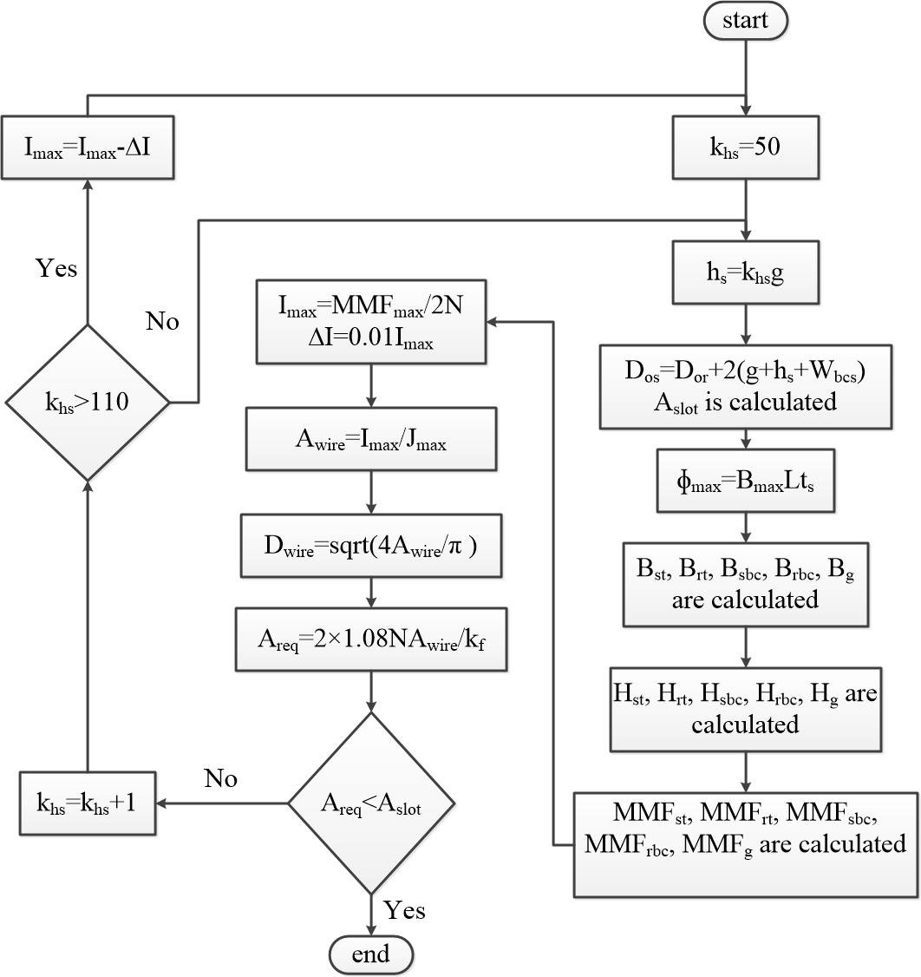

After determination of maximum allowable current, rated current of the machine is set to 90% of the maximum permissible current to consider a 10% of safety margin. If the winding current is more than maximum value, some problems related to winding temperature and insulation will be faced.



Once the rated current of SRM is determined, chopping circuit specifications are set. Maximum and minimum chopping currents are set 5% higher and 5% lower than the nominal current respectively.





After determination of number of turns per pole and wire dimeter, winding resistance has to be calculated. Accurate calculation of phase resistance is an important step in determination of both copper losses and dynamic characteristics of the SRM. First step in computation of winding resistance is calculation of copper length. Winding length of a pole pair can be calculated easily using



Where  represents mean stator tooth width. Note that due to tooth tapering effect tooth width is in its minimum value on motor bore, and gains its maximum near stator back core section. The coefficient of 1.3 is added to take the effect of end winding length into account. Therefore, resistance of two poles of one phase which are in series can be computed.



In this equation,  and  stand for wire resistivity and wire area respectively. A 3-D model of a typical 8/6 SRM is shown in the following figure in which end windings can be easily distinguished.

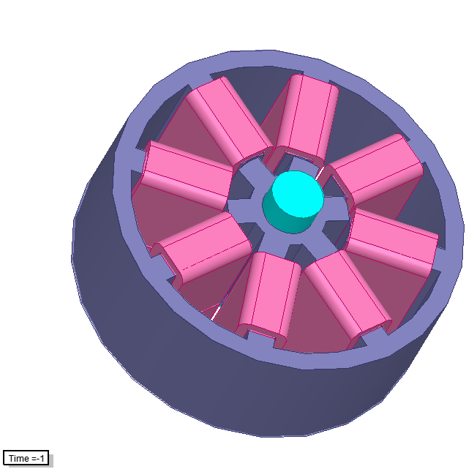

The discussed analytical design method is capable of designing any SRM for different Ns/Nr combinations by receiving seven input variables which are independent variables of optimization and were discussed in details in previous sections. Once the design process of the machine is complete, analytical calculations which was discussed in previous chapters are carried out in order to determine static and dynamic performance characteristics of the SRM.

**Analytical calculations of the designed machine**

At this stage machine geometric dimensions have been fully designed. On the other hand, motor winding, drive circuit and chopper circuit specifications have also been determined. Using the analytical method described in previous chapters, static and dynamic characteristics of the SRM are predicted.

First, static torque-position-current and flux linkage-current-position characteristics of the SRM are predicted. In prediction of static data, three artificial neural networks trained using Ertan’s data are implemented. Based on the method proposed for force and permeance calculations on asymmetrically slotted geometries, normalized permeance, force and MMF are calculated in teeth and air gap regions. Three corresponding equations are given below.







Note that in stator and rotor teeth the distance equivalent to 40g from the air gap is considered inside teeth and air gap region. The rest is taken into account in back iron MMF drop calculations. The following figure represents two teeth-air gap and back iron regions in a typical 8/6 SRM.



In the next step, MMF drop on motor back iron is computed. Finally, the static characteristics of the machine is predicted. A detailed description of implemented analytical method can be found in previous chapters.

Static torque and flux linkage data sets are used to train two neural networks which will be used in dynamic calculations of the SRM. A repetitive 4th order Runge Kutta method is implemented in order to compute the dynamic behavior of the SRM. Instantaneous phase currents and developed torque characteristics are calculated for the SRM. It is obvious that overlaps between conduction in consecutive phases are taken into account in computations.

It is noticeable that the end winding leakage effect is not taken into account in analytical calculations, because as mentioned earlier the tabulated normalized permeance, MMF and force data are obtained using 2-D finite element simulations. However, the effect of end leakage was discussed in the previous chapter by comparing analytical calculations and finite element simulation results while considering end leakage effect, and it is proved that end leakage inductance does not have a significant impact on analytical calculations results. Therefore, end leakage inductance effect can be neglected in analytical calculations.

At the end, core and copper losses, efficiency and motor mean torque per active mass are calculated. Thus, by giving seven input variables as an input vector to the analytical model average torque per motor active mass (TMM) is calculated for each machine as the objective function of the optimization.

The above-mentioned design procedure and analytical calculations method will be implemented in handling optimization problem. Upcoming sections deal with description of optimization procedure.

**Optimization method and tool**

At this stage, the problem can be considered as a mathematical optimization problem. The aim is to find optimum motor geometry and excitation pattern for each pole combination of switched reluctance machines in which torque density has its maximum value. Therefore, having a seven input and one output function in hand which has to be maximized, the most appropriate optimization method can be implemented.

Because the problem has many local maximum and minimum values, optimization method which are based on derivative methods are not suitable to solve this problem. For this purpose, Genetic Algorithm (GA) method, which is derivative-free and used search method in order to find the optimum point is implemented.

Flow chart of the optimization algorithm is shown in the following figure.

